8.1 prop test r function

prop.test(x=c(x1,x2),n=c(p1,p2),alternative = "greater", correct = FALSE) #(408,288) =(n1,n2)→test p1-p2>0.

8.2 (look for independent/dependant)

Conditions for t-test to test dif between two pop means

R code when given data

(pay attention to equal or not equal of test for the pool)

(paired = false is independant)

t.test(y1,y2,alternative = c("two.sided"),var.equal = TRUE,conf.level = 0.95,paired = FALSE)

R Code for dependant

9.1)



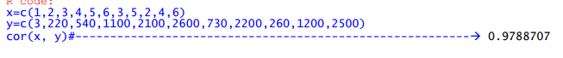



Keyword here is ~tends to decrease

For null/alternative tests~ linear correlation = alternative, no linear correlation ~null

Ex. Claim strong linear correlation ~ alternative ~ end up rejecting null, then there is enough evidence to say there is a linear correlation

Section 9.2

Note looking for meaningful means that the asked value is inbetween our given data set

mod<-lm(y~x)

summary(mod)

(multiple values below)

Interprettting the standard error

Coefficient of determination is MULTIPLE R SQUARED

INTERPRETATION:

